NAME: **AREEFA SAMAR**

ROLL NO: **CT-25062**

DEPARTMENT**: CSIT**

SECTION: **B**

**QUESTION 01: MARKS REPORT**

A school stores students’ marks for 3 terms in a 3D array where:

The first dimension represents the students (up to 5), The second dimension represents the subjects (up to 4), and the third dimension represents the terms (3).

Write a program to:

Input marks for all students, subjects, and terms. Calculate each student’s average marks per term and their overall average. Display the highest overall scorer and the term in which they performed best.

**SOURCE CODE:**

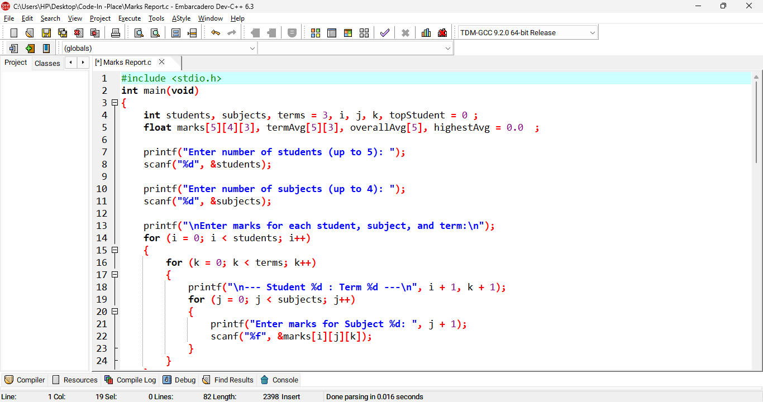

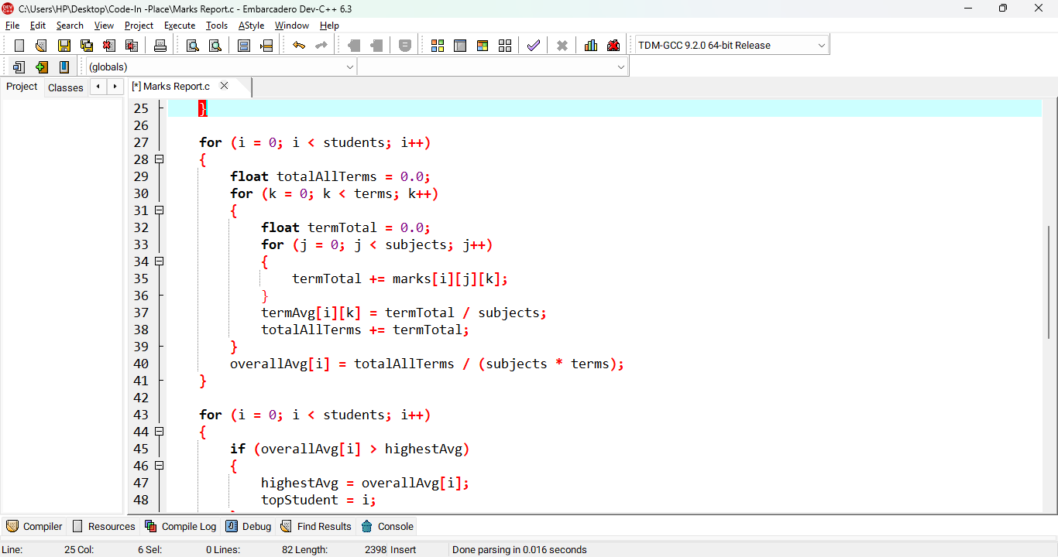

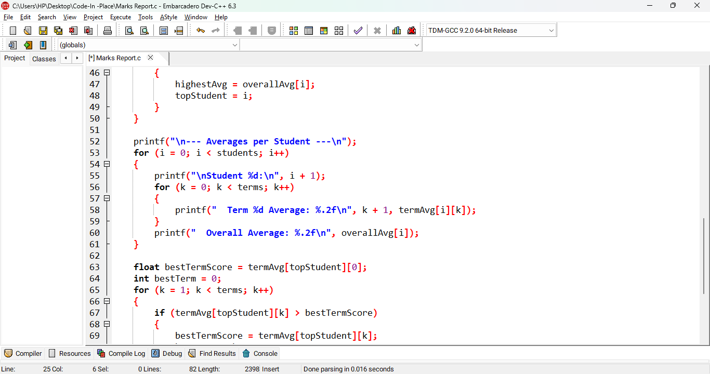

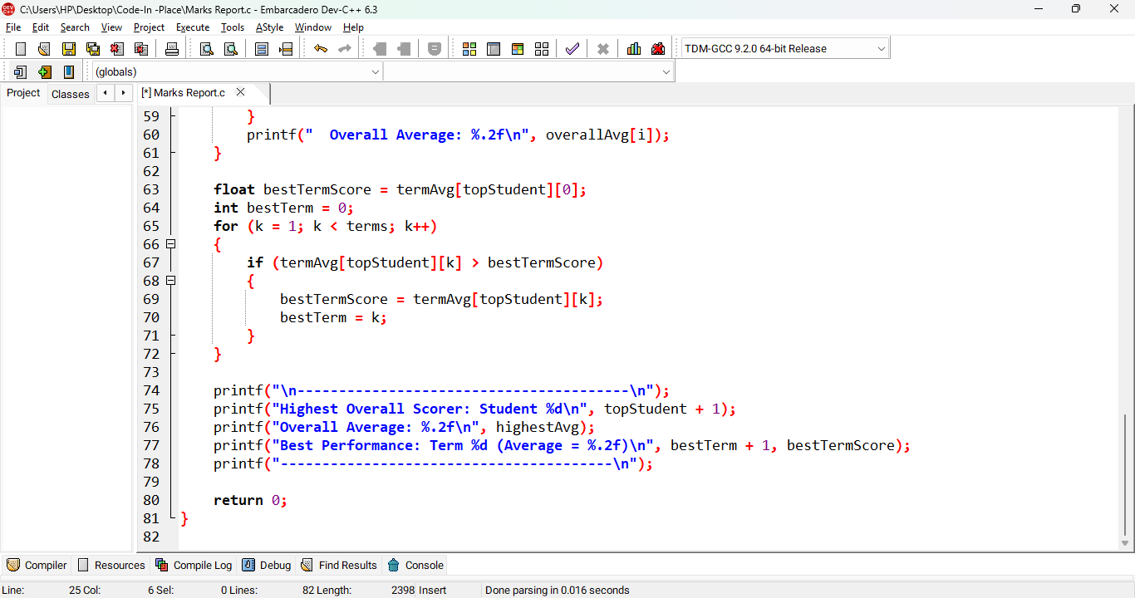

**OUTPUT:**

